A sketch, by definition, is a quick and loose freehand drawing. Although it may sound like a very casual form of drawing, it is nonetheless a very powerful representational technique in interior design. It allows the designer to very quickly read and record a space as well as helping a designer to rapidly and effectively explain a concept, a design idea, or a project detail.

Sketching is a form of communication in which an interior designer can communicate their ideas through drawings. The process of sketching is open to interpretation, and each designer will have their own style and technique. Unlike technical drawing, sketching is a medium with no rigid rules or boundaries, but it is also learnt and improved through practice. Understanding how to work with the key elements of visual expression (i.e. line, tone, texture, pattern, colour, form and space), will help achieve an effective sketch.

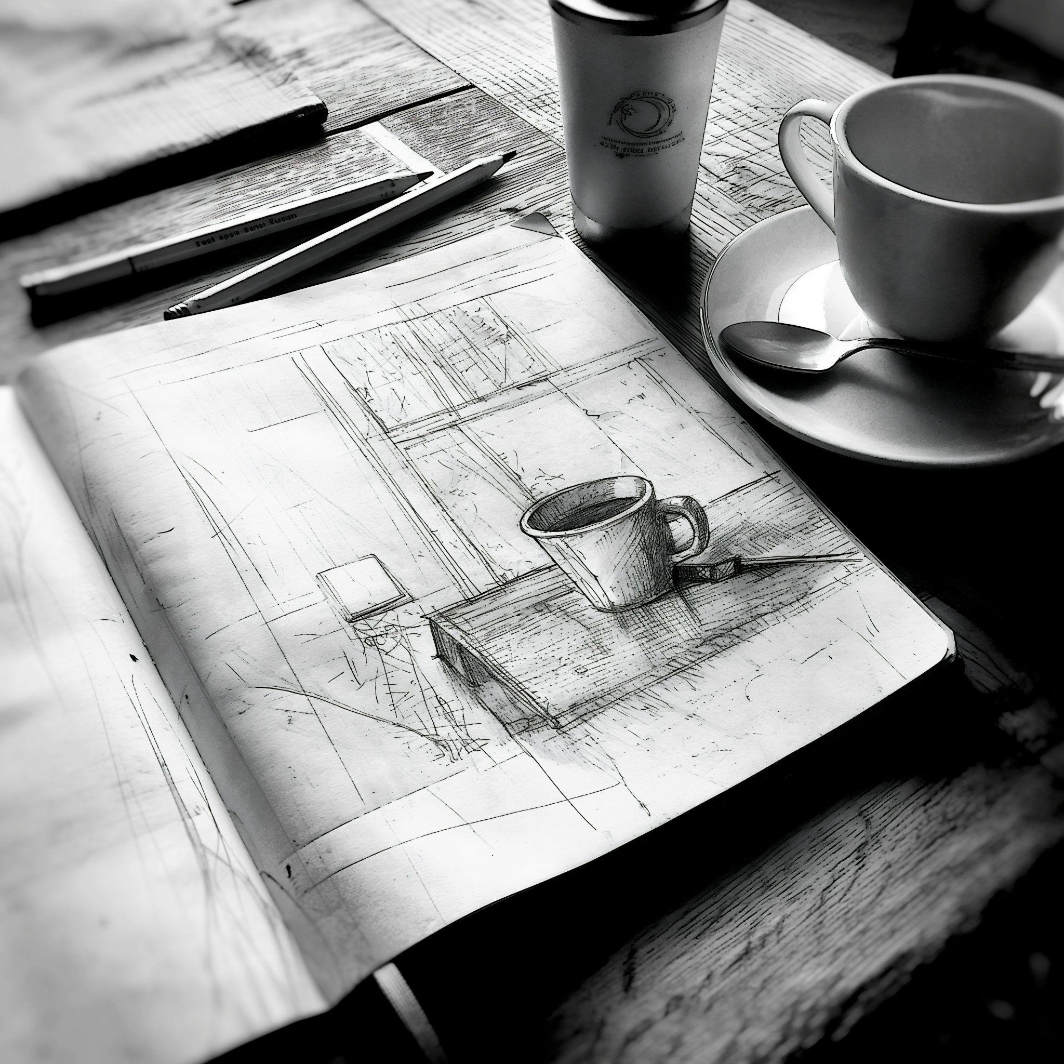

Fig. 1. Unsplash (n.d.), Sketch

Sketches can be “squiggles” on paper, or more sophisticated representations. This means that sketching can assume different forms and implement different techniques, depending on their use. Although there is no specific theory through which this can be analysed, it can be helpful to categorise sketches according to their nature and usage, in order to identify their set purposes:

## Conceptual

Concept sketches are usually produced at an early stage of the design process to explore different approaches to the design. When settled with a given direction, the conceptual sketch will continue to be part of the process as an attempt to show ‘the essence of a complex idea’, while trying to communicate design intentions in a clear, concise and effective manner.

Nonetheless, as your interior design project progresses, you might need to come back to these more abstract sketches, to revisit the initial concept and update designs further down the line of the Design Cycle.



Fig. 2. Unsplash (n.d.), Concept sketch

Conceptual sketches can assume many forms; from more abstract ones (e.g. exploring shapes and forms for a bespoke chandelier or piece of furniture) to more concrete ones, such as conceptual perspectives, elevations, plans, and sections.

## Analytical

Throughout the design process, there are several moments in which you will need to analyse the space and its elements. This is where analytical sketches play an important role. At the beginning of the project, you will need to conduct a site survey to analyse and collect information about the space. You will use, for example, sketches of the floor plan and elevations to more effectively take notes on-site. Then, as the design is developed, and to communicate a design intention in a more specific and concrete manner, analytical sketches can again come in handy in order to ascertain the potential zones within a room, or sketches of furniture layout plans for example. As the design process comes to completion, analytical sketches can still be important to rapidly explain ideas related to specific aspects of the installation and construction, particularly when dealing with construction teams on site.

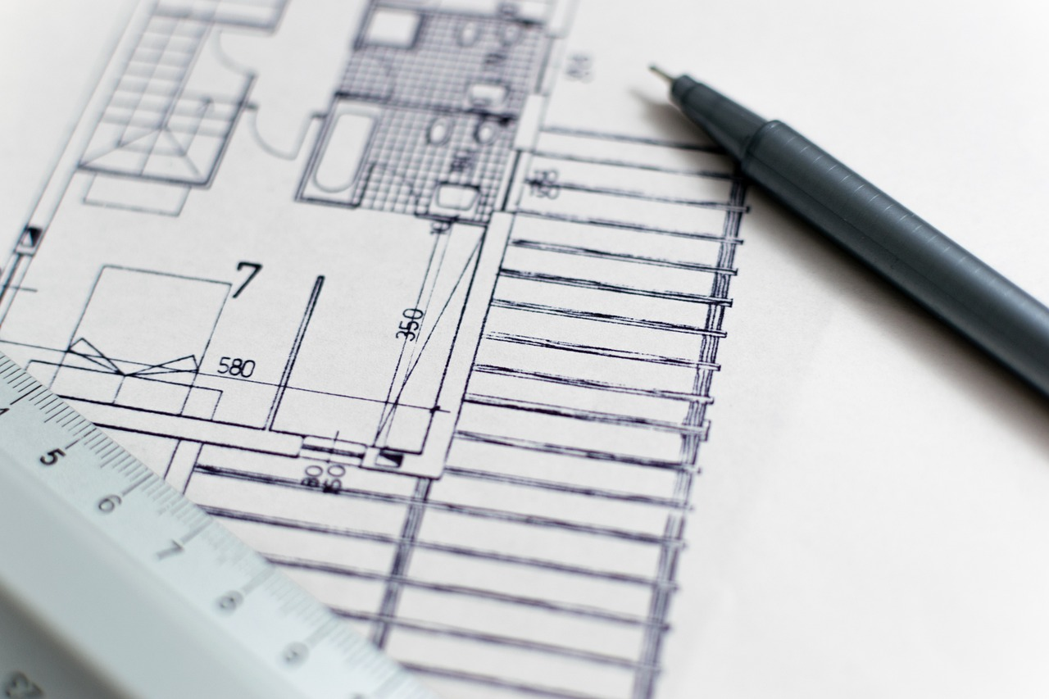

Fig. 3. Unsplash (n.d.), Floorplan

Analytical sketches can therefore assume the form of freehand plans or elevations, helping to analyse its form and the relationship between its different components. It is important to note that these drawings are not to scale, and should not be confused with Technical Drawings, but they should be sketched as much in proportion as possible, in order to communicate the intention more accurately.

## Observational

In some cases, it is helpful to have the ability to carefully observe a space and its elements in order to absorb and assimilate its essence. Then it can be recorded in a drawing. This makes observational sketches a key tool for the interior design process. These sketches usually take more time, and are descriptive and carefully considered in terms of the framing of the elements, the view, the light, and the details. They explore aspects of the space in greater detail, such as features, materials, textures, colours, etc.

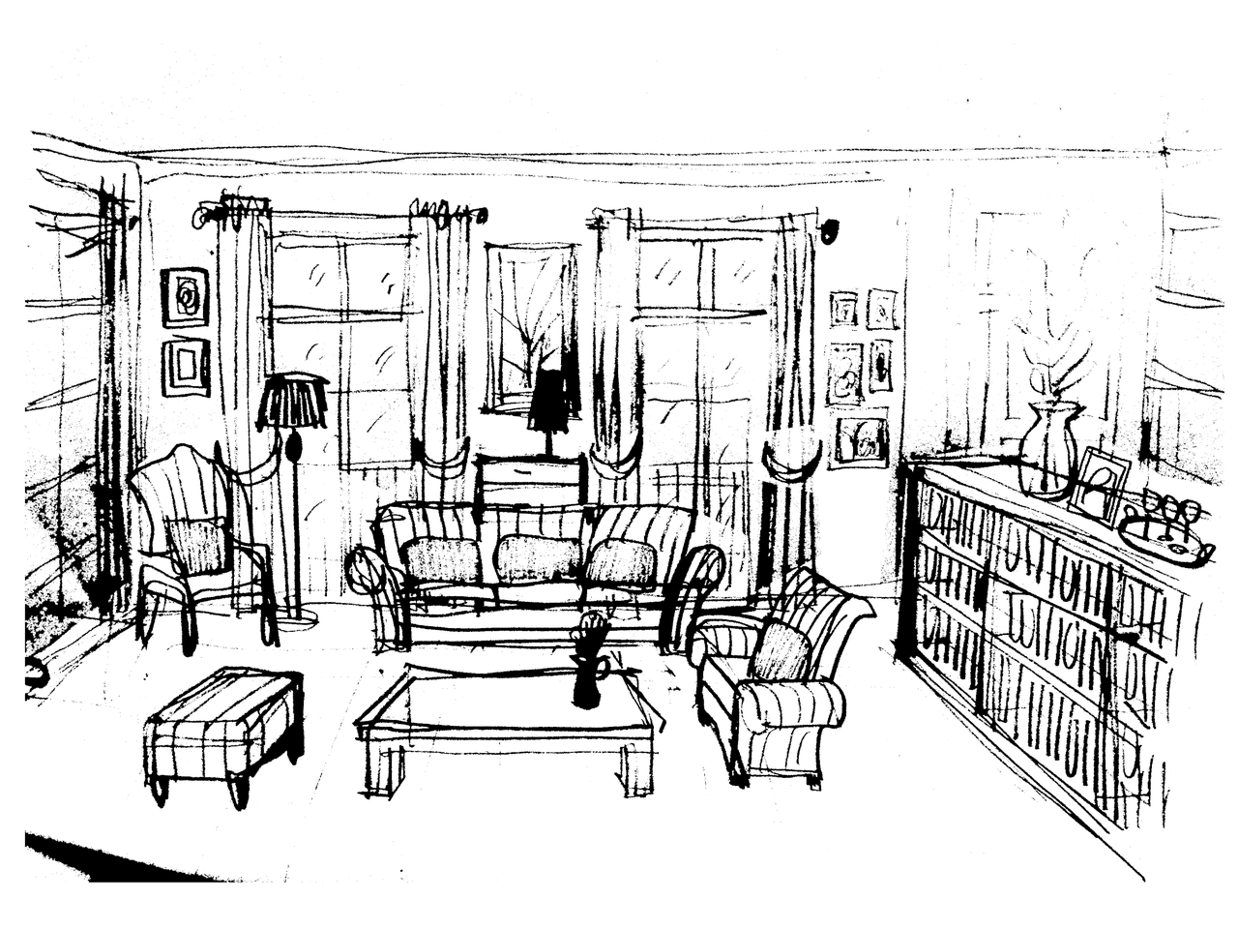

Fig. 4. Pixabay (n.d.), Observation sketch

Observational sketches are usually three-dimensional, more sophisticated 3D representations, such as perspective drawings, which are often rendered to show the finished outcome. Something important to note is that observational sketching is valuable during the design process as well as in the day-to-day of any designer. Practising this type of sketching is important because it will allow the designer to develop their sensitivity and spatial awareness, expanding their visual vocabulary and critical thinking, which will then help to better inform their future design work.

Sketches play an invaluable role in many stages of the design and development of an interior design project proposal.